**Trade Reconciliation** refers to a set of post-**trade** activities (typically T+0 or T+1) related to identifying and resolving **trade** breaks. We created Zap automation that update Trade reconciliation for entries in excel sheet with values obtained from internal application.

**Step 1:** Open an excel file.

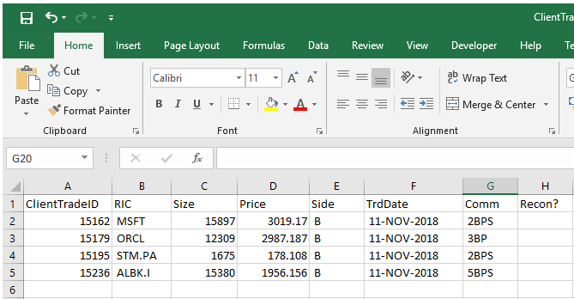

**Set the cursor on the row and the column from where your data entry starts.**

**Step 2:** Open internal application - **Trade Matcher.exe**

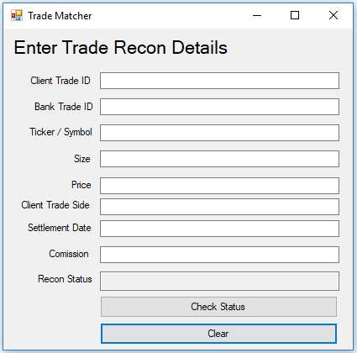

**Step 3**: Double click on **TradeReconAutomation.zappy** Automation.

**Step 4:** Run Zappy Task Window will pop up. Click on **OK**.

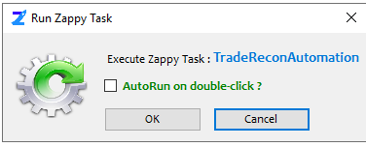

Zap automatically paste each row contents from the excel sheet to the internal application and clicks on Check Status. Recon Status obtained is copied into excel sheet.

**Output:**

